“Is Your Sales Portfolio Performing?”
Cliff Quicksell, MAS+
www.QuicksellSpeaks.com
Work Sheet
Company Portfolio, Value, Differentiators ____________________________________________________________________________________________________________________________________________________________________________________________________________________________________________________________________________________________________________________________________________________________________________________________________________________________________________________________________

Financial & Marketing Planning
____________________________________________________________________________________________________________________________________________________________________________________________________________________________________________________________________________________________________________________________________________________________________________________________________________________________________________________________________
Vertical Markets ___________________________________________________________________________________________________________________________________________________________________________________________________________________________________________________________________________________________________________________________________________________
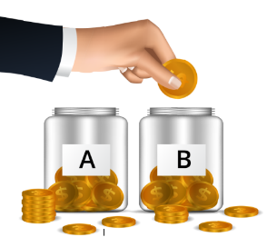 Classification & Diversification – What qualities do each of these categories exude
A – Blue Chip: __________________________________________________________________________________________________________________________________________________________________________________________________________________________________
B – Great Performer: __________________________________________________________________________________________________________________________________________________________________________________________________________________________________
Is Your Sales Portfolio Performing?
Cliff Quicksell – www.QuicksellSpeaks.com / 301.717.0615
Page 2
C – Average Performer: __________________________________________________________________________________________________________________________________________________________________________________________________________________________________
D – Below Average Performer: __________________________________________________________________________________________________________________________________________________________________________________________________________________________________
E – Low Performer: __________________________________________________________________________________________________________________________________________________________________________________________________________________________________
F – Dismal Performer: Time to sell – List the clients you need to fire. __________________________________________________________________________________________________________________________________________________________________________________________________________________________________
H – HOLD: (Explained) _________________________________________________________________________________________________________________
I – Inactive: (Explained) _________________________________________________________________________________________________________________
P – Prospect: (Explained) _________________________________________________________________________________________________________________
Portfolio Valuation – **Not Scientific
A _____ x ________ = $ ____________________
B _____ x ________ = $ ____________________
C _____ x ________ = $ ____________________
D _____ x ________ = $ ____________________
E _____ x ________ = $ ____________________
F 10 x $ 0.00 = $ 0.00

