Is Your Sales Portfolio Performing?
Cliff Quicksell – www.QuicksellSpeaks.com / 301.717.0615
Page 3
Marketing Strategies – Methods to Grow Sales & Profits
- Organically - _______________________________________________________________________________
- Reactivate Inactive Clients - ______________________________________________________________
- Prospecting - ______________________________________________________________________________
- Acquisition - ________________________________________________________________________________
Budget Strategy
Consider 4% - 6% of Gross Sales Allocated to You Marketing Budget
2019 Annual Sales $ ___________________________ x 4% = $ ___________________________________________________
Allocation:
80% toward A/B Clients $ ____________________ 20% of this allocated to prospecting $ ____________________
20 % allocated C/D/E clients $ _____________ & _______% of this toward Inactive Accounts $ ______________
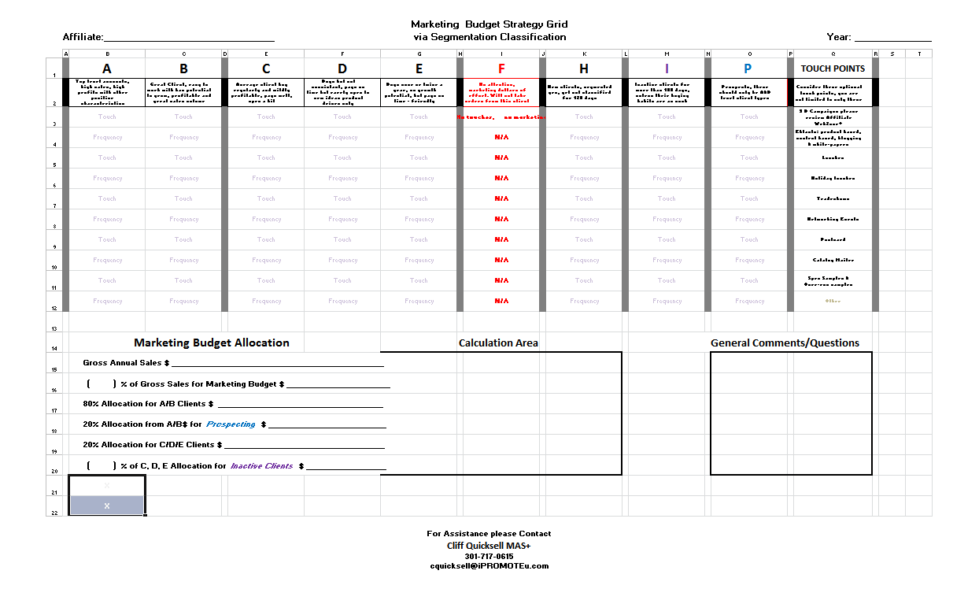
H – Hold Pattern ________________________________________________
I – Inactive and Resuscitation _____________________________________
P – Prospecting _________________________________________________
Is Your Sales Portfolio Performing?
Cliff Quicksell – www.QuicksellSpeaks.com / 301.717.0615
Page 4
F – Mitigate Your Risk – How would you propose handling existing “F” type clients
_________________________________________________________________________________________________________________
E – Methods to market to this segment –
_________________________________________________________________________________________________________________
D – Methods to market to this segment –
_________________________________________________________________________________________________________________
C – Methods to market to this segment –
_________________________________________________________________________________________________________________
B – Methods to market to this segment –
_________________________________________________________________________________________________________________
A – Methods to market to this segment –
Digital Marketing

Is Your Sales Portfolio Performing?
Cliff Quicksell – www.QuicksellSpeaks.com / 301.717.0615
Page 5

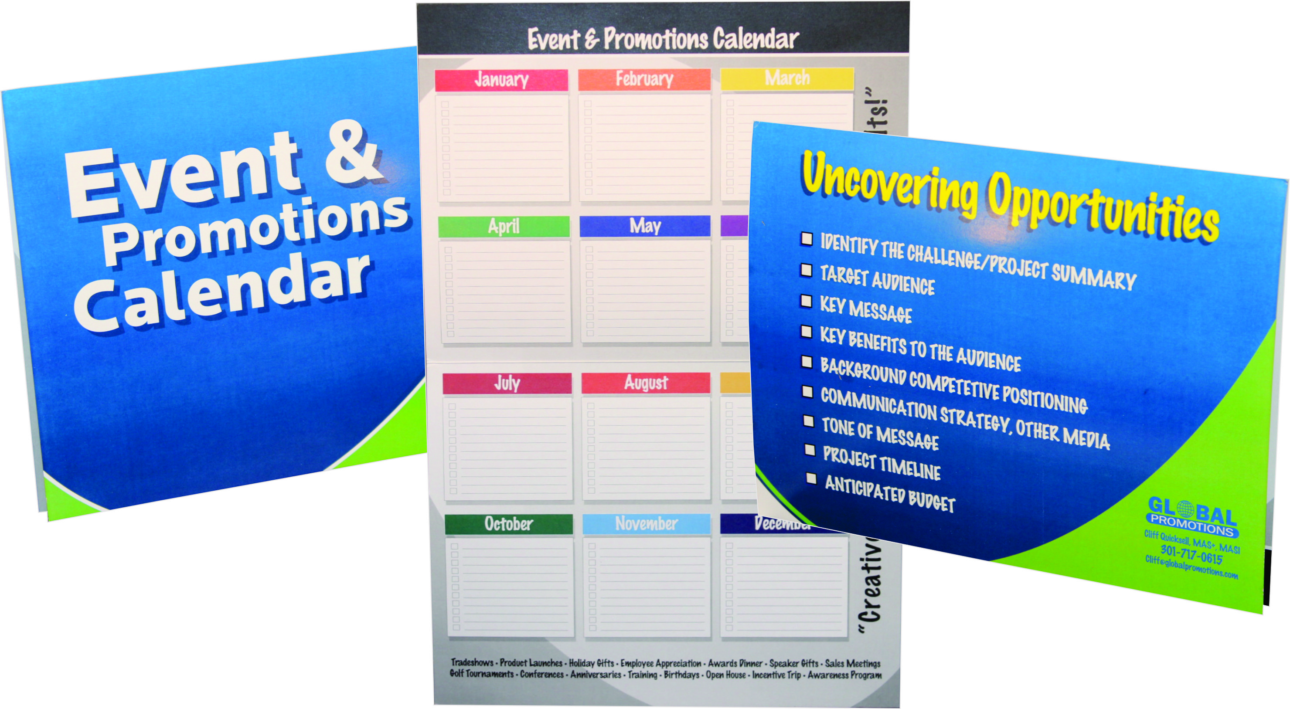Mailings

Direct Dimensional Mailings

High-End Marketing Pieces

Is Your Sales Portfolio Performing?
Cliff Quicksell – www.QuicksellSpeaks.com / 301.717.0615
Page 6

Ways a Coach Can Help
________________________________________________________________________________________________________________________________________________________________________________________________________________________________________________________________________________________________________________________________________________________________________________________________________________________________________________________________________________________________________________________________________________________________________________________________________________________________________________________________________________________________________________________________________________________________________________________________________________________________________________________

If you are interested in a full-blown, fully-detailed PowerPoint presentation, please email me at the following: Cliff@QuicksellSpeaks.com – Mark subject line as follows: My Sales Portfolio

Cliff Quickell, MAS+
301.717.0615
www.QuicksellSpeaks.com

